NRFC Slow Data Integration– Implementation (low level) Design

Document Information

DOCUMENT CONTROL AND AMENDMENT HISTORY
This section will describe the nature of and reason for any changes to the document.
Authors | Date Issued | Version No. | Nature of the Change | Reason for Change
Mary Sarafraz |  | 0.1 | Initial release

APPROVALS
Name | Role

Distribution List
This document has been issued to the following people for information.
Name: | Position:
As approvals list

Related Documentation
Doc Reference: | Title: | Author:
1 | Functional Presentation.pptx
2

Pending Confirmations
The following items require confirmation as they impact design and implementation:
- Historical Data Retention: Does any entities (or silver) require full historical retention for future analytics and reporting use cases)
- Confirm Lakehouse Design
- Confirm Lakehouse name
- Confirm Lakehouse structure, naming conventions, and layout
- Domain Model: Confirm domain definitions and naming (e.g., Finance, HR, Clients & Matters)
- Whether source systems implement logical deletes only or also support physical deletes

Document Purpose & Scope

Purpose
This document defines the implementation-ready, low-level technical design for NRFC’s slow (batch) data integration solution using Microsoft Fabric.
In addition to standard integration components (data flows, transformations, and execution patterns), this design includes selected platform, governance, and operational elements to provide a complete, implementation-ready solution.

This approach is driven by NRF Canada’s transition to a federated model, first-time adoption of Microsoft Fabric, absence of established platform standards, and tight delivery timelines.
As a result, the document establishes baseline guidance for platform setup, security, naming, Lakehouse design, domain ownership, monitoring, and schema management.
These additions ensure clarity for delivery teams, accelerate implementation, and provide a reusable foundation for future Canada Fabric initiatives.
This document serves as the authoritative build specification for engineering and delivery teams.

Non-Standard Sections
The following sections are not traditionally part of an integration LLTD and are typically defined in separate architecture or governance documents:
Section Area | Description | Typically Owned By
Fabric Tenant Configuration | Tenant-level setup, sharing, and external access configuration | Platform Operations / Cloud Architecture
Workspace Strategy & Environment Setup | Dev/Test/Prod structure, capacity planning, and promotion model | Platform Operations
Naming Standards | Naming conventions for Lakehouse, tables, pipelines, and artifacts | Data Governance / Platform Standards
Security Model & Access Control | Entra ID groups, RBAC, OneLake roles, and access patterns | Platform Security Architecture
Lakehouse Design & Structure | Data layering, folder structure, and storage layout | Data Architecture
Domain Model | Data ownership and governance boundaries based on business domains | Data Governance / Data Mesh Architecture
Schema Change Management | Contract-driven schema evolution and governance processes | Data Governance / Data Contracts
Monitoring & Observability | Logging, monitoring, and operational visibility patterns | Platform Operations / Support

Scope
In Scope
- NRF Microsoft Fabric tenant configuration relevant to Canada
- NRFC Fabric workspaces (Dev, Test, Prod)
- Canada Lakehouse design (single logical lakehouse)
- Fabric pipelines for orchestration (not ingestion)
- Fabric Notebooks for data transformation
- Fabric Shortcuts for logical data sharing
- Publishing Canada canonical (Gold) data to Global Fabric
- Receiving global reference data
Out of Scope
- Global Fabric workspace implementation (owned separately)
- Azure Databricks processing logic
- Real-time / streaming integrations
- Business logic definition (predefined in canonical model)

Project Definition and Background

Project Definition
The NRF Canada Slow Data Integration Initiative is a data integration project that supports NRF’s transition from a single, centralized global SAP system (GPMS SAP) to a federated regional operating model, where each region owns and manages its own data, while NRF Global shifts to a thin control and exchange layer.
The project ensures seamless bi-directional integration with global data workspaces, enabling them to continue receiving consistent and reliable Canada data and providing data to downstream global systems after GPMS SAP is decommissioned.
This project enables Canada’s regional data to be transformed into a global standard model (canonical model) and published to NRF global data workspaces, supporting enterprise reporting and integrations as the centralized GPMS SAP is retired. It also enables the Canada Fabric workspace to receive and consume global reference data and standards.
The project supports the interim state around Canada’s SAP go-live in September 2026, ensuring continuity of global reporting and integrations throughout the transition to a federated regional operating model.
The Canada Initiative goals are to:
- Enable governed bi-directional data exchange between NRF and NRFC
- Provide curated Canada data to the NRF global data layer in the form of a canonical model
- Consume curated global reference, taxonomy, and cross-region datasets from the NRF Gold layer within the NRFC transformation stage
- Receive data from Canada source systems (SAP ECC 6, SAP BW, Workday > RMDRPlus) into the Canada data platform
- Establish a Canada regional integration layer that reads source data once and supports multiple downstream use cases, eliminating repeated point-to-point integrations and redundant extracts
- Establish RMDRPlus as the authoritative regional systems of record

Project Background
The NRF Canada Slow Data Integration Initiative is driven by a combination of technology lifecycle constraints, strategic operating model changes, and the need to ensure continued global reporting and regulatory compliance while regional systems evolve independently.
A primary driver is the end of support for GPMS SAP in March 2027, which necessitates the decommissioning or modernization of the existing SAP-based Global Practice Management System (GPMS). NRF member firms, including Canada, the United States, EMEA, and Australia, have collectively decided to transition toward a fully federated regional operating model, replacing tightly coupled global dependencies with regionally owned Financial Management Systems (FMS).
Under this model, the legacy GPMS estate—including GPMS SAP, intermediate global databases such as GMDR and GMDD, and direct integrations feeding global downstream systems—is deconstructed.
As a result, a thin global data layer remains in place as a control and exchange layer to support global integration (including parent region scoping and cross-region data sharing), compliance processes, marketing processes, and consolidated global reporting.
In support of this federated operating model, NRF member firms have adopted region-specific FMS systems as follows:
- US and EMEA are developing the Aderant FMS system
- Canada is implementing a regionally owned SAP ECC system hosted on Google Cloud (GCS), replacing Canada’s dependency on GPMS while reusing SAP lineage rather than executing a greenfield ERP replacement

High-Level Architecture Overview
As illustrated in the “NRFC Slow Integration – High-Level Technical Integration Flow,” Canada operates as a federated data producer within the NRF analytics ecosystem. Canada owns its regional source systems and is responsible for ingesting, transforming, and curating its data using Microsoft Fabric, which serves as the unified data integration and transformation platform.
All data movement follows a pull-based batch (slow integration) model, ensuring regional independence and minimizing coupling with global consumers. Source data is accessed using OneLake shortcuts (zero-copy) and incrementally processed within the medallion architecture, with transformations primarily occurring in the Silver and Gold layers. The Gold layer acts as the formal data contract and export boundary for downstream global consumption and reporting.
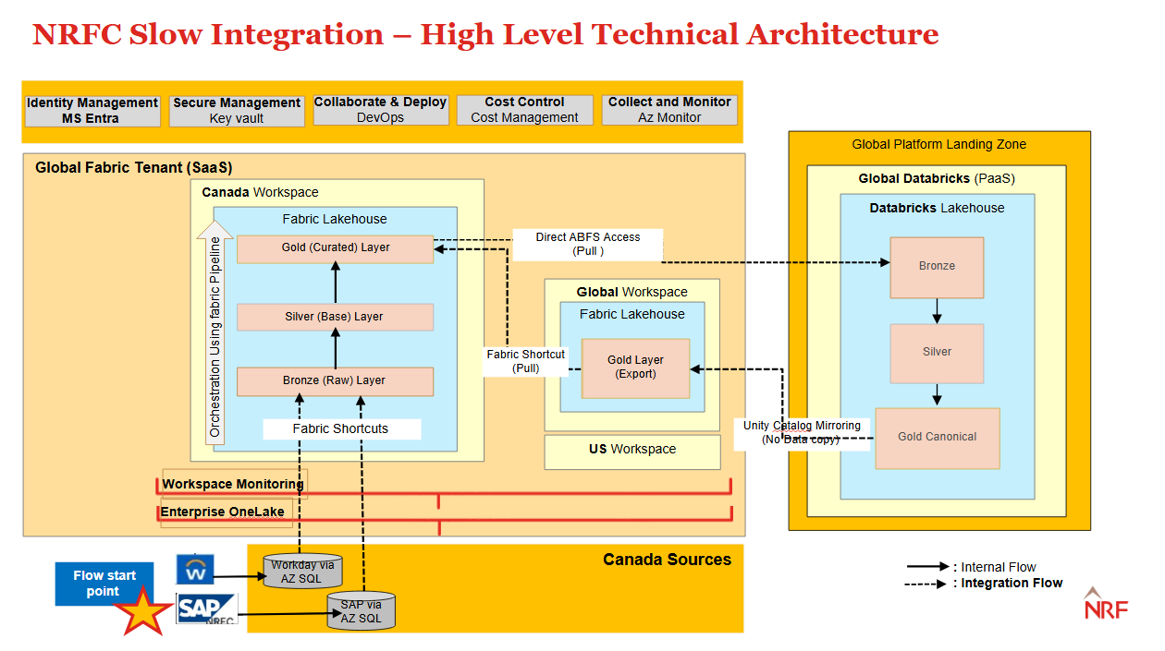

Architecture Components:
- NRF Fabric Tenant (SaaS): Enterprise Microsoft Fabric tenant hosting Canada, global, and other regional workspaces
- Canada Fabric Workspace (NRFC Workspace): Regional workspace where Canada data ingestion, transformation, and curation occur
- Fabric Lakehouse: Central storage and processing layer implementing Bronze (logical via shortcuts – DB Mirroring), Silver, and Gold layers
- OneLake Shortcuts: Primary mechanism for zero-copy, pull-based access to Canada source systems and global Fabric datasets
- Fabric Pipelines: Orchestration layer used for scheduling and execution of processing workflows
- Fabric Notebooks: Incremental transformation, data quality enforcement, and canonicalization logic across layers
- Global Fabric Workspace: NRF’s global control and exchange layer providing reference, taxonomy, and cross-region datasets
- Azure Databricks (Consumer): Global analytics and reporting platform consuming canonical Gold data via direct OneLake (ABFS) access
- Security & Access Control: Entra ID-based authentication, Fabric RBAC, and OneLake data access roles enforcing least-privilege access
- Azure DevOps: Source Control & Deployment with Git integration supporting version control and environment promotion (Dev/Test/Prod)

Fabric Tenant & Workspace

NRF Fabric Tenant
- Tenant: NRF
- Platform model: Microsoft Fabric (SaaS)
- Authentication & authorization: Microsoft Entra ID
- Fabric home region: UK South
- Configure: OneLake sharing and data access settings
Who: Fabric (Tenant) Administrator
Path: Microsoft Fabric Admin Portal → Tenant settings → OneLake settings → data sharing settings.
- Configure: External data access
Who: Fabric (Tenant) Administrator
Path: Microsoft Fabric Admin Portal → Tenant settings → External data access / OneLake settings
Note: Required for Direct OneLake / ABFS access from Databricks
- Configure: Cross-workspace data sharing
Who: Fabric (Tenant) Administrator
Path: Microsoft Fabric Admin Portal → Tenant settings → Data sharing / External & cross-workspace access
Note: Used by Workspace admins through workspace permissions and OneLake shortcuts.
- Configure: Fabric Git integration and policies
Who: Fabric (Tenant) Administrator
Path: Microsoft Fabric Admin Portal → Tenant settings → Git integration
  - workspace admins to connect workspaces to Git
- Cross-region sharing is supported within the same tenant and governed through workspace permissions and data access controls (no separate tenant-level toggle required)
- Networking: No customer-managed VNets required for Fabric (SaaS-managed platform)

Environment Strategy (Dev/Test/Prod)
The environment strategy defines where and how all development, testing, and production deployment activities are performed within the NRFC Fabric platform.
Three isolated environments are established:
• Dev: Used for development, experimentation, and initial validation
• Test: Used for integration testing, validation, and user acceptance
• Prod: Used for production workloads and consumption by downstream global systems
Each environment is implemented as a separate Fabric workspace with dedicated capacity, security groups, and configurations.
All environments follow a consistent structure, naming standards, and configuration to ensure controlled promotion, repeatability, and governed deployment across the lifecycle.
Promotion between environments is managed through Azure DevOps pipelines with Git integration, ensuring version control and controlled releases.

NRFC Fabric Workspace Setup
NRFC Fabric workspaces define environment boundaries (Dev, Test, Prod). They are not data layer boundaries. All environments follow an identical structural pattern and are promoted through controlled CI/CD pipelines, with no environment-specific logic embedded in notebooks or artifacts.

Environment | Workspace Name | Capacity | Capacity Region
Dev | ws_canada_global_mds_dev | F8 | Canada Central
Test | ws_canada_global_mds_test | F16 (scale to F64 during testing) | Canada Central
Prod | ws_canada_global_mds_prod | F64 | Canada Central

Standardization Rules
- Identical workspace structure across Dev / Test / Prod
- Promotion of artifacts via CI/CD pipelines only (after initial phase)
- No hard-coded environment logic in notebooks, or pipelines
- Configuration managed via parameters and pipeline variables

Workspace Permissions
After creating each workspace, assign access to the appropriate admin group based on the environment:
Environment | Group
Dev | NRFC-PIMGroup-Fabric-DevAdmin
Test | NRFC-PIMGroup-Fabric-TestAdmin
Prod | NRFC-PIMGroup-Fabric-ProdAdmin

Source Control Configuration
This section defines the required platform setup and permissions to enable Fabric source control integration using Azure DevOps.

- Azure DevOps Admin: Project and Repository Setup
- Azure DevOps project (if not already existing). Name: NRFC_Global_Fabric_Integration
- Create Git repository for Fabric source control
- Configure default branch (e.g., main)
- Define repository visibility and access mode
- Azure DevOps admin: Access and Permissions:
- NRFC Git Admins (Entra ID Security Group)
- Repository administration
- Project Contributor (create and mange repo structure)
- NRFC Development Team (Entra ID Security Group)
- Contribute and Pull Request permissions
- No permissions to manage Git connection settings
- NRFC Git Service Principal (SPN)
- Identity for automated Git operations
- Repository read/write and PR permissions
- Repo Admin: Repository Setup
- Enforce branch protection policies on main
- Create baseline Git structure (refer to section 7.2)
- Create and manages branches
- Define branching strategy
- Fabric workspace Admin: Fabric Git Integration
- Define initial sync direction (repo ↔ workspace)
- Connect workspace: Fabric Workspace → Settings → Source Control → Connect
- Bind repository, branch, and root folder (/fabric)
Cross-References
- Section 9.1 – Publishing is driven by repo sync
- Section 11.1 – Pipeline schedules are version-controlled
- Section 10.1 – Align with identity and access model

Naming Standard
A consistent naming strategy ensures that every data asset or artifact is uniquely identifiable and understandable, regardless of where or how it is accessed within the platform.
These standards are mandatory and enforced across all environments.

General Rules:
- Use lowercase only
- Do not use spaces
- Do not use dots (.)
- Do not use special characters
- Use underscore (_) as the standard separator
Note: These naming standards apply to Fabric platform artifacts (Lakehouse, tables, pipelines, notebooks) only. External system names (e.g., SAP, Workday, Azure SQL) follow source system naming conventions

Lakehouse
lh_canada_global_mds

The lakehouse name lh_canada_global_mds (where lh stands for lakehouse) indicates the type and scope of data stored within it, showing that it contains Canada-specific data aligned to global master data (MDS) domains for easy identification and governance.

Schemas (logical layers):
- Bronze: raw
- Silver: base
- Gold: curated
- external_curated

Tables:
- Bronze (shortcuts / raw):
  - raw_<source>_<entity>
- Silver (base):
  - base_<entity>
- Gold (canonical / curated):
  - curated_<domain>_<entity>
- Global reference (external):
  - global_reference_<entity>
  - global_cross_region_<entity>

Pipelines:
- pl_<source>_<layer>_<purpose>

Notebooks:
- nb_<layer>_<entity>_<purpose>

Fabric Identity, Authentication & Access
This solution uses a group-based security model, where all access is managed through Microsoft Entra ID security groups with no direct user-level permissions.

Security is enforced through a layered Fabric model across three levels: authentication, authorization, and data security. The overall strategy is defined in the High-Level Design; this section describes the implementation using Entra ID groups, workspace roles, item permissions, OneLake access roles, and data-level controls to enforce least-privilege access.

Security Model Overview
Security is enforced through three cumulative layers. Access is granted only when all layers allow it.

Layer 1 – Entra ID (Authentication)
Purpose: Verify identity
- Users, service principals, or managed identities must authenticate via Entra ID
- Provides SSO, MFA, and conditional access
- Does not grant access to Fabric or data

Layer 2 – Fabric Authorization (Control Plane Access)
Purpose: Control access within Fabric
- Workspace roles:
  - Viewer: Read-only access
  - Contributor / Member: Create and modify artifacts
  - Admin: Full control
- Item permissions:
  - Applied to Lakehouses, tables, SQL endpoints
  - Restrict access beyond workspace roles
- Item permissions further restrict access even if a workspace role is assigned.
- Workspace roles control UI access but do not grant data access.

Layer 3 – Data Security (Data Plane & Exposure Controls)
Purpose: Control data access and exposure
Databricks access, OneLake data access roles are the primary enforcement layer. Workspace roles provide access to Fabric artifacts, while OneLake data access roles enforce storage-level permissions, especially for external compute access.
- OneLake data access roles:
  - Control file and folder access (Read, Write, Manage), these roles do not support masking or filtering
  - Enforced for external compute (e.g., Databricks via ABFS)
  - Do not support masking or filtering
- Data exposure controls (SQL endpoint only):
  - RLS (row-level security)
  - CLS (column-level security)
  - Data masking

Entra ID Security Groups and Service Principals
The Entra ID team is responsible for creating the required security groups and service principals.

Security group
All access is managed using Entra ID security groups.
- Entra ID team creates and manages groups and membership
- Groups are used consistently across Fabric, OneLake, and downstream components
- Full group list is defined in the appendix
- All changes must be reviewed and approved by NRFC

Role × Entra ID Group × Security Layer Matrix
Defines how roles map to Entra ID groups and security layers. Detailed environment-specific mappings are provided in the appendix.

Permission Provider (Role) | Entra ID Security Group (Consumer) | UI Path (Where Permission Is Granted)
Workspace Admin | NRFC-Fabric-Workspace-Contributor | Fabric Workspace → Settings → Manage access → Add role (Contributor)
Workspace Admin | NRFC-Fabric-Workspace-Viewer | Fabric Workspace → Settings → Manage access → Add role (Viewer)
Workspace Admin | NRFC-Fabric-Automation-Contributor | Fabric Workspace → Settings → Manage access → Add role (Contributor)
Tenant Administrator | NRFC-Fabric-Tenant-Admin | Microsoft Fabric Admin Portal → Tenant settings → Assign Fabric Admin
OneLake Security Admin | NRFC-Fabric-Lakehouse-Write | Lakehouse → Manage access → OneLake data access roles → Grant Write
OneLake Security Admin | NRFC-Fabric-OneLake-Write | OneLake → Manage access → Data access roles → Grant Write
OneLake Security Admin | NRFC-Fabric-Databricks-OneLake-Read | Lakehouse (Gold) → Manage access → OneLake data access roles → Grant Read
OneLake Security Admin | NRFC-Fabric-OneLake-Read | OneLake → Manage access → Data access roles → Grant Read
OneLake Security Admin | NRFC-Fabric-OneLake-Manage | OneLake → Manage access → Data access roles → Grant Manage
Data Owner / SQL Admin | NRFC-Fabric-Data-Masked | Lakehouse SQL Endpoint → Security → Apply RLS / CLS / Masking
Data Owner / SQL Admin | NRFC-Fabric-Data-Unmasked | Lakehouse SQL Endpoint → Security → Grant object-level access

Entra ID Service Principals
The Entra ID team provisions the required service principals. A separate read-only service principal is created per Azure SQL source system to enforce least-privilege access and independent lifecycle management.

- nrfc-data-fabric-azsql-sap-ro-sp
- nrfc-data-fabric-azsql-workday-ro-sp
- nrfc-data-fabric-azsql-sap-ro-sp -prod
- nrfc-data-fabric-azsql-workday-ro-sp-prod

In addition, a dedicated service principal is required per environment (Dev/Test/Prod) to support CI/CD pipeline execution and secure automated deployments.

CICD SP names

Fabric Lakehouse Design
Lakehouse Name: lh_canada_global_mds
The Lakehouse name reflects the platform (lh), region (Canada), and data scope (global master data services). “MDS” is used instead of referencing specific technologies (e.g., Databricks) to maintain platform independence and flexibility

Lakehouse Structure
The design uses a single Lakehouse per workspace to centralize storage and simplify governance.
Medallion layers (Bronze, Silver, Gold) are implemented logically using schemas, folders, and naming conventions rather than separate physical lakehouses. Domain structures (e.g., Finance, People, Matter) are implemented within the Lakehouse to support ownership and scalability.

Canada Fabric Domain Model
Domains are defined as part of the Global Fabric governance model and may be represented in Fabric governance and catalog features.
In this implementation, domains are applied logically within the Lakehouse structure (naming, folders, and ownership) rather than as enforceable platform-level objects.

A two-level domain hierarchy is used:
- Level 1 (Region): CAN
  - Aligned globally with: AUS, CAN, EMEA, GLOBAL, SA, USA
- Level 2 (Business domain):
  - Finance, HR, Knowledge, Clients & Matters, etc.

Lakehouse Structure Layout
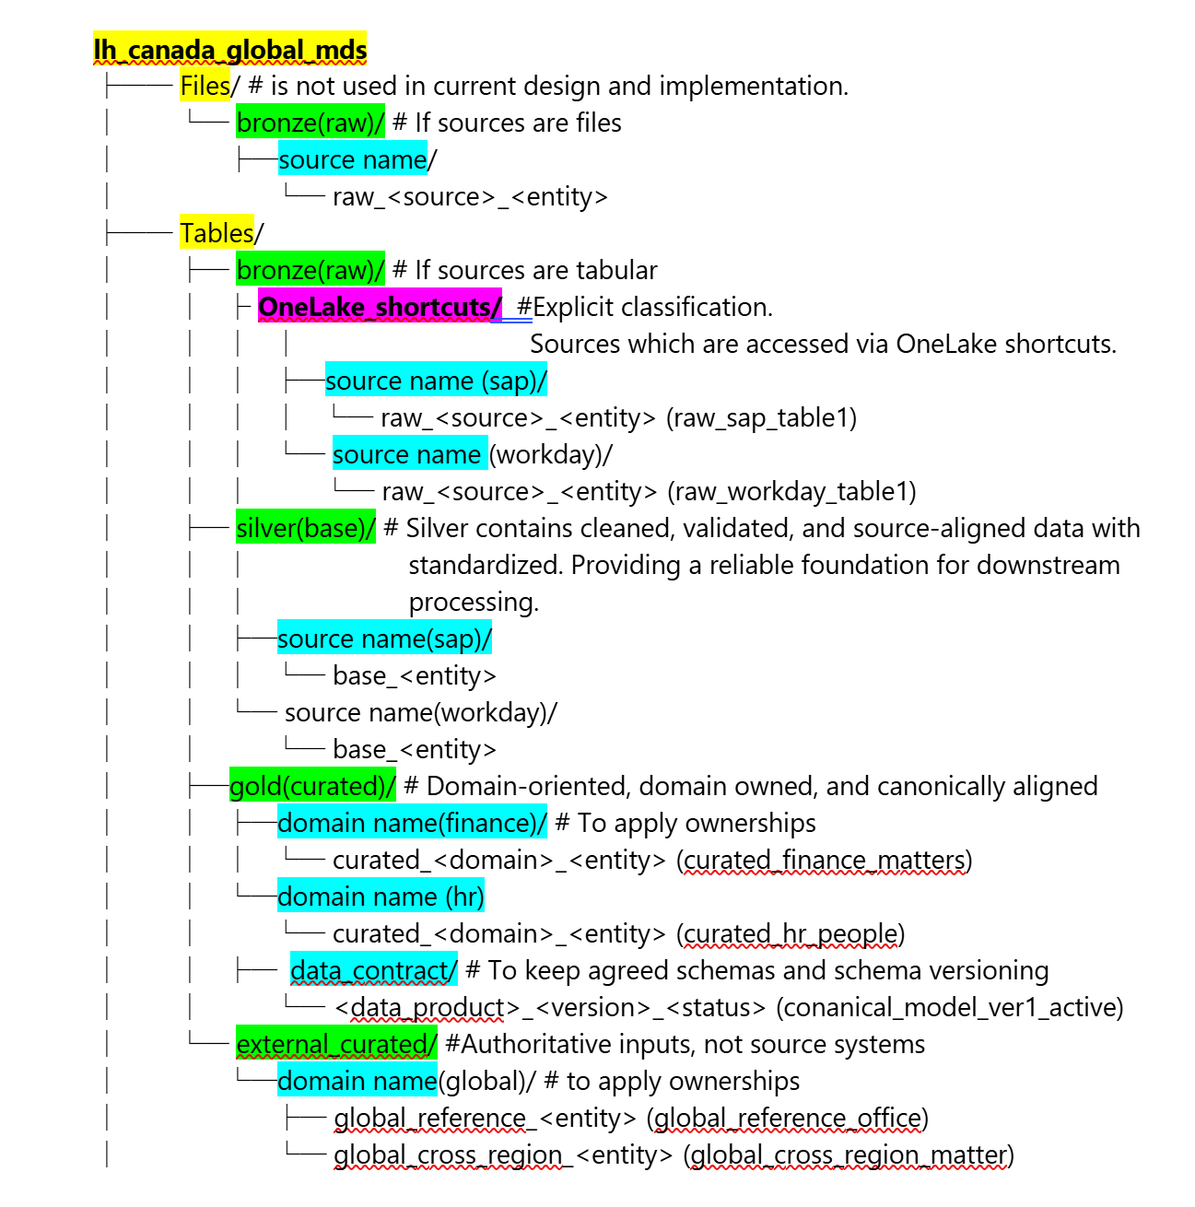
*Sources SAP and workday were replaced to a combined single source RMDRPlus

Source Control Integration
This section defines how Fabric artifacts participate in source control, what is included, and what is explicitly excluded.
Fabric Git integration versions design-time artifacts:
- Fabric notebooks
- Fabric pipelines
- Lakehouse metadata (existence, name, configuration)
- Supported workspace artifacts
These artifacts are synced as files to Git and participate in standard PR-based workflows

Excluded from Git:
- Table schemas (Silver / Gold)
- Column definitions and constraints
- Delta logs and data files
Table schema changes executed via notebooks are not tracked in Git by default through Fabric Git integration. These changes must be separately defined and version-controlled in the repository (e.g., via DDL scripts) to ensure proper schema versioning.

Repository Structure
Repository structure reflects artifact types (not data layout) and separates Fabric-synced artifacts from non-Fabric artifacts (schemas, contracts, CI/CD).
This structure supports artifact lifecycle management while keeping runtime data concerns out of Git.

Fabric Artifact Layout:
Repo root (nrfc_fabric_integration)
├── README.md
├── .gitignore
├── fabric artifacts/ ← Fabric-synced artifacts
│├── notebooks/ -à If sources are files
││└── raw/
│││├── nb1
│││└── nb2
││├── base
│││├── nb1
│││└── nb2
││└── curate/
││ ├── nb1
││ └── nb2
│├── pipelines/
││└── conformance/ #
│││├── pl1
│││└── pl2
││└── transformation/ #
│││├── pl1
│││└── pl2
││└── Orchestration/ #
││ ├── pl1
││ └── pl2
│├── lakehouses_meta/
││└── <lakehouse-name>/
││ └── lakehouse.json # Fabric‑managed metadata only
│└── artifacts.md# What is expected in Fabric Git

Non-Fabric Artifacts Layout
Repo root (nrfc_fabric_integration)
├── Lakehouse_schemas/# Lakehouse DDL (NOT Fabric Git)
│├── Bronze/
││└── *.sql
│├── Silver/
││└── *.sql
│└── Gold/
│ └── *.sql
│
├── data-contracts/
│├── Gold/
││└── <dataset>.yml
│└── README.md
├── ci_cd/
│├── pipelines/
││├── schema-deploy.yml
││├── fabric-sync.yml
││└── validation.yml
│└── scripts/
│ └── deploy_schemas.sh
├── environments/
│├── dev/
││└── config.yml
│├── test/
││└── config.yml
│└── prod/
│ └── config.yml
│
└── docs/
├── architecture.md
├── lakehouse-design.md
└── operational-notes.md

Bronze Layer – Raw

Purpose
The Bronze layer is implemented as a logical layer only, with no physical data storage in Fabric. It provides a source-aligned, logical raw access layer without physical data ingestion.

Source-Aligned Schema Definition
As the Bronze layer is strictly aligned to source system contracts and the upstream sources are tabular (SQL Server), Bronze is implemented using tables only, preserving source schemas, table structures, and column definitions without transformation

- Source-aligned schemas (RMDRPlus)
- Access via OneLake shortcuts (no data storage in Fabric)
- No transformation or data quality checks
- Not directly consumable
- Supports pull-based processing into Silver
Bronze schemas are aligned to canonical source definitions documented in:
20260424 CanonicalModel-Attributes - Shared.xlsx

Data Structure
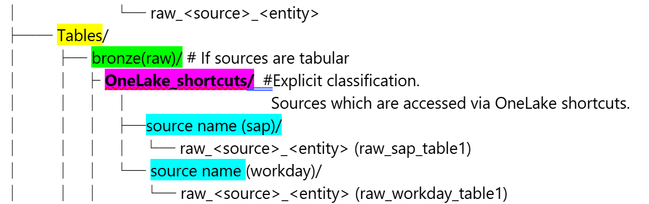
*Sources SAP and workday were replaced to a combined single source RMDRPlus

Governance & Ownership
Governance in the Bronze layer focuses on ensuring raw data capture integrity with no transformation or enrichment, maintaining full lineage and traceability from source systems, and restricting access to technical and engineering roles only. Change and governance coordination at this layer is limited to source-level events such as onboarding new sources, source decommissioning, and ingestion failures or format changes. Any downstream semantic or business impact resulting from these changes is governed in the Silver and Gold layers.

- Canada business domains: source onboarding and data completeness
- Canada IT (Delivery team): connectivity, ingestion patterns, platform controls
- Global: defines source scope and ingestion requirements

Silver Layer – Base
Silver (base) focuses on technical correctness, structural consistency, and source-aligned data.

Purpose
The Silver (Base) layer provides cleaned, conformed, and source-aligned datasets derived from the Bronze layer. It standardizes data structures and types, applies foundational data quality rules, and prepares data for downstream canonical and business transformations.
Silver serves strictly as a clean, governed foundation for downstream canonical (Gold) modeling. It is optimized for consistency, reuse, and traceability, but not for business consumption.

Standardized Incremental Transformation Pattern
- Delta tables in Lakehouse
- Incremental loads based on source timestamps
- Full history via Delta versioning
- One notebook per source table
- No cross-source harmonization
- No business-level transformations
Schemas aligned to canonical definitions documented in:
20260424 CanonicalModel-Attributes - Shared.xlsx

Standardize and Data Quality Rules
Silver tables are source-aligned but cleaned. At this layer, basic DQ validations are enforced:
- Null checks on mandatory business keys
- Primary / natural key enforcement (reject or deduplicate duplicates)
- Deduplication using source keys + last modified timestamp
- Data type casting to canonical standards (e.g., dates, numeric, codes)
- ISO code is used for storing data
- Dates are stored as UTC
- Value Normalization Examples: “Y / Yes / true” → true
- Canonical Conformance/ harmonization Transforming source-specific values into standard, agreed canonical values using lookup/reference tables.
- Row count checks
- No referential alignment across SAP and Workday where applicable
- Basic referential alignment within SAP and within Workday where applicable
- No advanced DQ scoring or monitoring
- Failed records are either excluded or flagged, depending on notebook logic.
- Utilize ISO Codes for Country and Currency and not a reference to the Taxonomy Country/Currency Primary Keys.

Data Structure
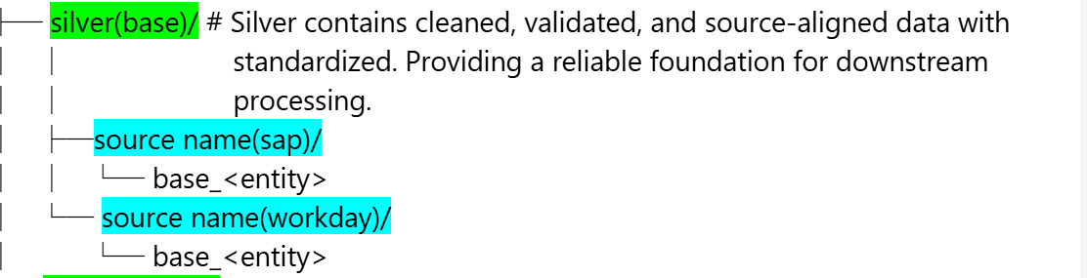
*Sources SAP and workday were replaced to a combined single source RMDRPlus

Governance & Ownership
Canadian domains (Finance, People, etc.) own (Data Ownership):
  - Data correctness and completeness for Canada
  - Source-system interpretation and mapping
  - Timeliness and ingestion reliability
  - Validation that data reflects what the source generated (no business reinterpretation)
Ownership here is technical and source-aligned, not business-semantic.
Global team own (Logic Ownership):
  - Standardization rules (naming, data types, normalization)
  - Global ingestion and harmonization patterns
  - Source-to-contract alignment requirements

Gold Layer - Curated
Gold layer focuses on who owns the data and logic. Data is transformed into canonical model. Gold (curated) data is domain-oriented and domain-owned.

Purpose
The Gold layer provides domain-oriented, Canada-specific canonical datasets that align 1:1 with the Global Canonical Contract.
This layer represents the authoritative, curated view of core business entities for Canada and serves as the formal data contract and governed interface for downstream consumption.

Scope & Canonical Entities
The Canada Canonical Gold (curated) layer includes the following canonical entities, aligned one-to-one with the global model:
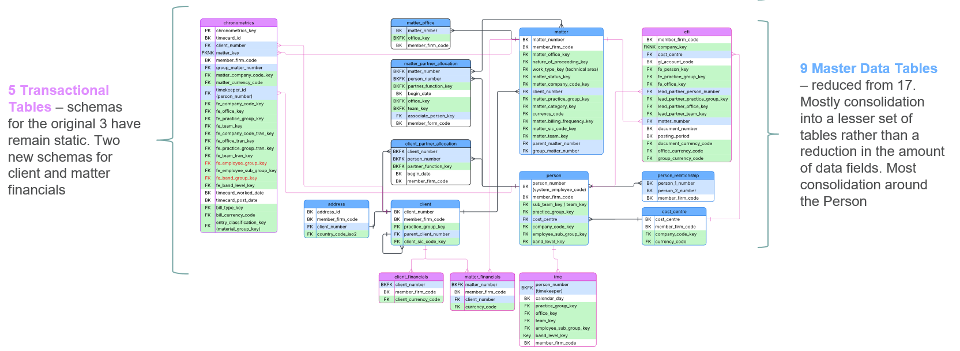

Global Canonical Alignment
- Gold is the single Canada canonical truth layer
  - All Gold entity schemas are exactly aligned with the global canonical model contract
  - No Canada-specific divergence at schema or contract level
  - Canada specialization is achieved through data content, not structure
- Delta tables stored in Fabric Lakehouse
- Incremental loads derived from Silver layer changes
- Full history retained using Delta Lake versioning, but no full historical retention logic (type 2 changes) implemented. Because analytics with be done through global.
- Canonical naming, keys, and relationships enforced at entity level
- Referential integration enforces on Canonical Models
- Transformations follow canonical mapping definitions
- Transformations are applied at the entity level only
- Schema versioning is managed at the data product level
- Logic includes:
  - Canonical field mapping
  - Cross-source harmonization (SAP, Workday)
  - Key standardization
Reference attribute definitions are in
  - 20260424 CanonicalModel-Attributes - Shared.xlsx

Data Structure
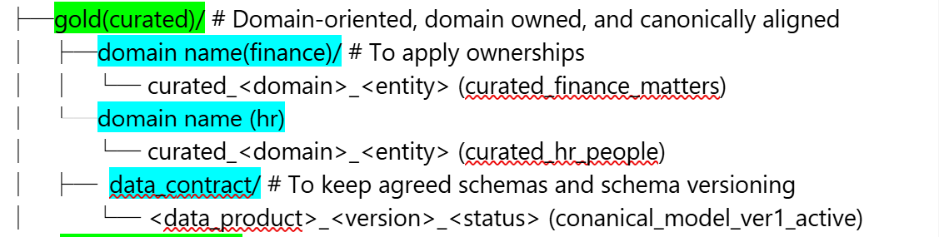

Governance & Ownership
Gold (curated) is the primary layer of ownership and stewardship. Ownership & governance formally live here. This layer is where change & governance coordination formally applies through data contracts.
Canada Business Teams Ownership (Finance, People, HR, etc.)
- Own Canada-specific data correctness and completeness
- Own source-system interpretation and local impacts
- Approve that global logic produces correct Canadian results
- Coordinate changes with Global based on contracts
Global Teams Ownership
- Owns data products, transformation logic, and global business rules
- Defines canonical models and contracts
Data - Contract
Contracts are used throughout implementation to enforce consistent, contract-driven data delivery. During design-time alignment, global canonical contracts are used to define and agree on schemas, attribute definitions, and versioning up front, ensuring that Canada’s Gold (curated) models conform to global standards. During build and validation, curated datasets are implemented and validated against contract schemas and data quality expectations. At this phase of the project, contract validation and compliance checks are performed manually, as automated contract enforcement and validation pipelines have not yet been implemented.
Contact Governance Responsibilities:
- Coordinate changes between Canada domains and Global
- Assess impact of source, contract, or schema changes
- Validate and approve changes before exposure
- Ensure alignment with federated governance standards

Contract-Driven Schema Change Management
Schema changes are evaluated against active data contracts and classified as:
- Non-breaking (additive, backward compatible)
- Breaking (type change, removal, key changes)
Handling approach:
- Non-breaking: applied as minor version updates without consumer impact
- Breaking (approved):
  - New contract version created
  - Gold (curated) updated
  - Published via versioned Gold layer
  - Consumers notified and migrated
- Breaking (rejected):
  - Processing blocked
  - No downstream changes applied
  - Issue logged and communicated
All changes are tracked in contract metadata, with full audit and versioning control.
Step by step schema change management process (schema drift handling step by step), including workflows and controls, is documented in the Appendix.

External Curated Layer

Purpose
The External Curated layer enables the Canada Fabric lakehouse to consume authoritative, globally mastered datasets that are owned and governed outside the Canada Fabric workspace. These datasets are not source systems and are not mastered locally.
External datasets are exposed via Fabric Shortcuts from Global Fabric workspaces and are consumed in a read-only manner, allowing Canada to align with global entities without data replication or local ownership.
The layer supports consumption of:
- Globally governed reference data (standard code sets and enumerations required for canonical conformance)
- Cross-region canonical entities required for global reporting, integration, and reconciliation

Data Structure
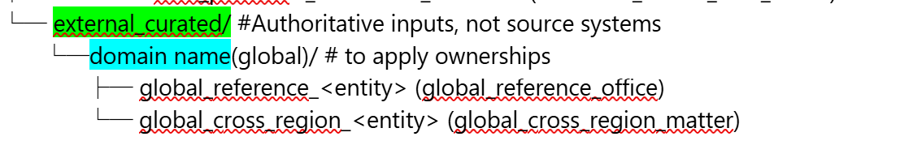

Governance and Ownership
Data ownership, schema control, and change governance remain with the global producing teams. Canada is responsible for compliant consumption only.
This approach ensures cross-region alignment, schema consistency, and elimination of data duplication and schema drift, while preserving global ownership.

Consumption Model and Usage Constraints
- Used as reference and lookup data to support canonical conformance
- Used for validation of controlled values and standard code sets
- Provides shared reference data across Finance, People, and Matter domains
- Read-only, consumer-driven access
- Exposed via Fabric Shortcuts from Global Fabric workspaces
- Consumed in Silver and Gold transformations
- No enrichment, mutation, or override performed in Canada
- Must remain 1:1 aligned with source schema and semantics

Data Masking
Masking is not currently enforced in NRFC, as data is only consumed by Azure Databricks and not exposed to business users.
Masking applies only at SQL/Fabric consumption layers and does not affect Databricks access.
If business users are introduced, masking will be enabled in alignment with global standards at the Silver and Gold layers.
The entities identified by global team for masking include FormAnswers, Client, Work, and Matter.

Data Movement & Processing

Fabric Data Factory Pipelines (not Used)
All source access is implemented using Fabric Shortcuts to Azure SQL, treated as the Bronze layer. Fabric Data Factory pipelines are not used in the current design. This section is retained as a placeholder to accommodate future changes should the data ingestion approach evolve.

Fabric Notebooks
Fabric notebooks are the primary mechanism used for data movement and transformation between Lakehouse logical layers in the Canada workspace. All data processing logic from Bronze to Silver and Silver to Gold is implemented using Fabric SQL notebooks.

Notebook Scope and Responsibilities
Fabric notebooks are responsible for the following processing stages:

Bronze (shortcuts) → Silver
- Read source data through Bronze shortcuts (logical access only)
- Perform data standardization and conformance
- Apply data quality (DQ) checks
- Handle missing or invalid reference values based on defined DQ rules
  - Flagged, or
  - Assigned a default/fallback value
Silver → Gold
- Apply business and canonical transformations
- Enforce canonical schema, keys, and business rules
- Produce curated, consumption-ready datasets

Incremental Processing and Merge Logic
All notebooks use an incremental processing model:
- Data is filtered using control columns such as last_modified_datetime
- Incremental MERGE logic is used to apply inserts and updates
- Truncate/reload patterns are not used
- Stable primary keys are required and enforced
This ensures efficient processing, auditability, and predictable behavior.

Reconciliation, Controls, and Audit Support
Each notebook includes reconciliation and control steps:
- Source-to-target row counts validation
- Record-level checks where required
- Schema validation and drift detection

Standard control columns include:
- Load timestamp
- Source system identifier
- Processing run identifier

Notebook Structure and Inputs/Outputs
Each notebook has a clear, well-defined responsibility:
- Input: Bronze shortcut tables or Silver tables
- Output: Silver or Gold (curated) delta tables
- Each notebook handles a single processing stage

Notebook execution runs as SQL Spark jobs within Fabric.

Parameterization and Environment Independence
All notebooks are parameterized to support:
- Environment separation (Dev / Test / Prod)
- Schema and database abstraction
- Reusable logic across deployments

Hard-coded environment values are not permitted.

Technology Standards
- SQL notebooks are the standard for all transformations
- PySpark notebooks are not used unless explicitly approved
- Fabric pipelines are not used for transformation logic

Fabric notebooks remain the single, controlled layer for data processing.

Fabric Pipelines (Orchestration)
Fabric pipelines are used exclusively for orchestration and scheduling of notebook execution. They do not perform data ingestion or transformation logic. This approach ensures clear separation of concerns between orchestration (pipelines) and processing logic (notebooks)
Pipelines Responsibilities:
- Triggering and sequencing notebook execution (Bronze → Silver → Gold)
- Managing execution dependencies between processing steps
- Scheduling batch runs based on defined frequencies (e.g., every 4–6 hours)
- Passing runtime parameters to notebooks (environment, schema, load windows)
- Monitoring execution status and handling failures (retries, alerts)

Design Principles:
- Pipelines orchestrate only; all transformation logic resides in notebooks
- Pipelines remain stateless and lightweight
- No data movement or transformation is implemented within pipelines
- Execution is aligned with incremental processing patterns

Processing patterns
This section describes the standard data processing patterns used across Canada Fabric workspace, focusing on incremental processing, delete handling assumptions, and the separation of orchestration and transformation logic.

Assumptions and Delete Handling
The design assumes logical deletes only.
- Logical deletes (for example, status flags or end-date columns) are supported and handled within transformation logic.
- Physical deletes, introduction of physical deletes requires explicit design review and processing changes.

Processing Patterns and Responsibilities
Two consistent processing patterns are used:
Silver Processing (Bronze → Silver)
- Purpose:
  - Data conformance and standardization
  - Data quality (DQ) validations
- Source: Bronze shortcuts (logical access only)
- Target: Silver delta tables
Gold Processing (Silver → Gold)
- Purpose: Business and canonical transformations
- Source: Silver delta tables
- Target: Gold delta tables

Design Principles
Processing patterns are designed to be:
- Incremental by default
- Non-destructive
- Auditable and deterministic
- Aligned with federated data ownership

Principles
- Pipelines orchestrate execution, dependencies, and scheduling.
- Notebooks implement all transformation logic.
- Pipelines contain no business logic.
- Notebooks are deterministic, incremental, and idempotent.

Any deviation from these patterns (for example, introduction of physical deletes) must be reviewed and explicitly approved.

Incremental Processing Pattern
Bronze → Silver
- Detect new or changed data using control columns
- Validate schema against target structure
- Apply DQ rules
- Perform MERGE operations using:
  - Business key
  - Row hash (change detection)
- No truncate or full reload operations

Silver → Gold
- Apply business and canonical transformations
- Use MERGE-based logic for inserts and updates
- Preserve history where required
- No destructive operations (delete/truncate)
- Preserve historical records where required
- No destructive operations (such as deletes or truncates) are permitted

Integration Patterns

ABFS Direct Access from Databricks

Overview and Data Setup
Global Azure Databricks reads Canada data directly from the Canada Fabric Lakehouse (OneLake) using ABFS access. This is a read-only, pull-based pattern used for engineering workloads only. Canada remains the system of record.
Data is stored as Delta tables in the Lakehouse. Tables use stable primary keys and include control fields (e.g., last_modified_datetime) to support incremental reads. Views, shortcuts, and semantic models are not used for this access path.
This approach provides efficient access for Databricks while maintaining ownership, structure, and governance within Canada Fabric.

Incremental Reads and Execution Model
Data access is pull-based and triggered by Global Databricks on a 4–6 hour schedule. Canada Fabric does not initiate processing for this integration.
Databricks reads incremental changes using control fields:
- Records with last_modified_datetime greater than the previous run
- Includes both new and updated records
- No full reload or truncate/reload patterns
No data is copied, and no pipelines are used for this integration

Security and Canada Setup
Global Databricks accesses OneLake using a Service Principal.
Access is enforced through:
- Fabric workspace roles (for logical access)
- OneLake data access roles (for storage-level enforcement)
Canada setup:
- Enable external data access in Fabric tenant settings
- Add Databricks Service Principal to Canada Fabric workspace
- Assign Workspace Viewer role
- Grant OneLake Read access to required Gold datasets
- No per-table permissions, OneLake security roles, or storage ACLs are needed.
If require, Fine-grained access (e.g., table or folder-level) is controlled through OneLake roles where required.
This pattern provides controlled, read-only access without introducing additional data copies or integration layers.

Fabric Shortcuts

Shortcut to Global Workspace
Fabric shortcuts are used in Canada Fabric workspace to access lookup and reference datasets published by Global Fabric workspace. This supports validation, conformance, and enrichment processing without data duplication. All access is read-only.
Source datasets are published by Global in a Global Fabric workspace (Gold layer) in a different region and are accessed using cross-workspace, cross-region OneLake shortcuts.
Fabric shortcuts are not used for:
- Large transactional datasets
- Performance-critical or high-volume processing
- Data consumption by external compute (e.g., Databricks)
- Scenarios requiring independent lifecycle or strict isolation

Reference, lookups and cross region datasets are primary datasets that accessed through Fabric shortcuts. These datasets are organized in the Canada Lakehouse under a dedicated lakehouse path External Curated Layer (section 7.7 of this report)
Currently, project team only creates and maintains the shortcuts for these cross-region datasets. The exact processing use cases are not yet defined. When used, data is consumed incrementally (new and updated records only).

Global Shortcut Implementation
- Verify access from Canada to Global workspace
- Create cross-workspace OneLake shortcuts
- Organize under external_products structure
- Use only for validation, conformance, and enrichment
- Do not modify or persist Global data in Canada

Authorization Model
- Global workspace grants Canada workspace Viewer access
- Canada creates read-only cross-workspace shortcuts

Access enforcement includes:
- Fabric workspace roles (discovery and access)
- OneLake data access roles (file-level enforcement, if required)
- No data movement, external compute access, or additional security configuration is required for this Fabric-to-Fabric pattern

Shortcut to AZ SQL Source Systems
Fabric shortcuts (DB mirroring) are used to create read-only pointers to Azure SQL source systems (SAP and Workday > Both merged into RMDRPlus). These shortcuts represent the Bronze layer boundary but do not physically store data.
Canada reads source data incrementally through shortcuts and writes results directly to Silver tables. Bronze is implemented as a logical layer only (no physical storage). It represents source-aligned data accessed via OneLake shortcuts and is not materialized. Source systems remain externally owned and managed.
These shortcuts must not be used for:
- Curated or Gold-level data
- High-volume analytical workloads
- Cross-domain or consumer-facing datasets
Only source system tabular data (tables or views) is accessed through Azure SQL shortcuts. The data is organized explicitly under the Bronze layer to clearly indicate source-owned data. Refer to section 7.3 Bronze Layer – Raw)

- Tables/ Bronze/ fabric_shortcuts/RMDRPlus/<schema>_<table_or_view_1>

These datasets represent raw source data and are not modified or enriched at this stage.

SQL Shortcut Implementation
Prerequisite: Ensure Fabric Service Principal is created and mapped to an Entra ID database user in Azure SQL with SELECT-only access to approved tables or views
- Create Fabric shortcuts to approved Azure SQL tables or views
- Organize shortcuts under the standard Bronze directory structure
- Use shortcuts as read-only logical references for incremental extraction into Silver
- No pipelines, ingestion jobs, or data materialization are required
- Fabric notebooks implement incremental processing logic

Authentication and Authorization Model
This permission model uses Service Principals for authentication because Azure SQL shortcut support for Fabric workspace managed identity is not documented or supported; all resources operate within the same Entra ID tenant and region.
Fabric connects to Azure SQL using dedicated Entra ID Service Principals (one per source system). These identities are restricted to read-only access.
Azure SQL enforces access by:
- Mapping Service Principals to database users
- Granting SELECT permissions on approved tables or views (preferably views for controlled access)

Operational Runtime & Support

Scheduling
All processing is scheduled to run every four hours using Fabric pipeline scheduling. If a job fails, automatic retries are triggered based on the configured retry policy to handle transient issues. Scheduling is designed to meet data freshness expectations while minimizing operational overhead.

Alerts & retries
Pipeline failures and critical events trigger automatic alerts, including email notifications and Microsoft notifications to the configured user group. Retries are handled automatically before alerts are raised to reduce noise and ensure only actionable failures are surfaced.

Monitoring & observability
Monitoring and observability are handled through Fabric Monitoring Hub and the internal Accelerator Framework monitoring. Runtime metadata is captured in mandatory control tables (control.pipeline_run_control, control.schema_drift_events, and control.dq_metrics) to support pipeline status tracking, data freshness validation, row-count reconciliation, and schema drift detection. Monitoring focuses on pipeline execution status, failure visibility, and data freshness, with no additional operational complexity introduced.

Constraints & Assumptions
The following constraints and assumptions apply to the Canada Fabric solution:
- Mapping definitions are provided and maintained by the Global team
- The Global Canonical Data Model is predefined and stable
- Canada Subject Matter Experts (SMEs) are available to clarify data and business rules
- Source data uses logical deletes
- Source systems provide stable primary keys
- Source systems provide control fields (e.g., last_modified_datetime) to detect changes
- Only standard data quality validations are applied (no advanced or custom DQ rules)

Appendix

Entra ID Security Groups – NRF Canada Fabric Integration
Naming Convention (used in here), Entra team may use their naming convention.
NRFC-Fabric-<Environment>-<Scope>-<Role>
- Environment: DEV | TEST | PROD
- Scope: Workspace | Lakehouse | Data | Automation
- Role: Admin | Contributor | Viewer | Read | Write | Manage

Fabric Security Groups & Scope
1. Fabric Workspace Access Groups
1.1 Workspace Admin Groups
Used for workspace lifecycle, security, capacity.
NRFC-Fabric-<environment>-Workspace-Admin
1.2 Workspace Contributor Groups
For data engineers and developers creating/modifying artifacts.
NRFC-Fabric-<environment>-Workspace-Contributor
1.3 Workspace Viewer Groups
For all read-only consumers (no authoring).
NRFC-Fabric-<environment>-Workspace-Viewer
2. Lakehouse Item-Level Permission Groups (Fabric Security)
Used for item permissions (Read / Write) on Lakehouses and tables.
2.1 Lakehouse Read (Consumers / Shortcuts)
NRFC-Fabric-<environment>-Lakehouse-Read
2.2 Lakehouse Write (Data Engineering Only)
NRFC-Fabric-<environment>-Lakehouse-Write
3. OneLake Data Access Role Groups (Storage / ABFS)
These groups are bound to OneLake Data Access Roles
(critical for Databricks and any external compute).
3.1 OneLake Read (External Compute / Consumers)
NRFC-Fabric-<environment>-OneLake-Read
3.2 OneLake Write (Engineering Pipelines Only)
NRFC-Fabric-<environment>-OneLake-Write
3.3 OneLake Manage (Very Restricted)
NRFC-Fabric-<environment>-OneLake-Manage
4. Shortcut Consumer Access Groups (Gold Only)
Used to grant Read access to the Lakehouse hosting shortcuts.
NRFC-Fabric-<environment>-Gold-Shortcut-Read
5. Automation & CI/CD (Service Principals Only)
5.1 Fabric Deployment & Promotion
NRFC-Fabric-<environment>-Automation-Contributor
Assigned to:
- CI/CD service principals
- Deployment pipelines
6. Azure Databricks Integration Groups
6.1 Databricks Read from Gold Export
NRFC-Fabric-<environment>-Databricks-OneLake-Read
7. Data Masking Control Groups (If Applied)
7.1 Unmasked Access (Engineering Only)
NRFC-Fabric-<environment>-Data-Unmasked
7.2 Masked Consumer Access
NRFC-Fabric-<environment>-Data-Masked
8. Fabric Admin Governance (Tenant Level)
8.1 Fabric Admin (Kept Empty by Default)
NRFC-Fabric-Tenant-Admin
Assigned via:
- Entra ID
- PIM only
- The tables are explicit, audit-ready, and actionable by Infra / Platform teams.

Environment Explicit Role × Entra ID Group × Security Layer Matrix
Environment: DEV | TEST | PROD

Permission Provider (Role) | Entra ID Security Group (Consumer) | UI Path (Where Permission Is Granted)
Workspace Admin | NRFC-Fabric-<environment>-Workspace-Contributor | Fabric Workspace → Settings → Manage access → Add role (Contributor)
Workspace Admin | NRFC-Fabric-<environment>-Workspace-Viewer | Fabric Workspace → Settings → Manage access → Add role (Viewer)
Workspace Admin | NRFC-Fabric-<environment>-Automation-Contributor | Fabric Workspace → Settings → Manage access → Add role (Contributor)
Tenant Administrator | NRFC-Fabric-<environment>-Tenant-Admin | Microsoft Fabric Admin Portal → Tenant settings → Assign Fabric Admin
OneLake Security Admin | NRFC-Fabric-<environment>-Lakehouse-Write | Lakehouse → Manage access → OneLake data access roles → Grant Write
OneLake Security Admin | NRFC-Fabric-<environment>-OneLake-Write | OneLake → Manage access → Data access roles → Grant Write
OneLake Security Admin | NRFC-Fabric-<environment>-Databricks-OneLake-Read | Lakehouse (Gold) → Manage access → OneLake data access roles → Grant Read
OneLake Security Admin | NRFC-Fabric-<environment>-OneLake-Read | OneLake → Manage access → Data access roles → Grant Read
OneLake Security Admin | NRFC-Fabric-<environment>-OneLake-Manage | OneLake → Manage access → Data access roles → Grant Manage
Data Owner / SQL Admin | NRFC-Fabric-<environment>-Data-Masked | Lakehouse SQL Endpoint → Security → Apply RLS / CLS / Masking
Data Owner / SQL Admin | NRFC-Fabric-<environment>-Data-Unmasked | Lakehouse SQL Endpoint → Security → Grant object-level access

Schema Drift handling step by step
All schema changes—including those requested by global teams—are evaluated against active contracts; non-breaking changes evolve existing versions, while breaking changes are either rejected or introduced exclusively through new versioned Gold (curated) contracts.

Schema changes can originate from:
- Incoming source schema (detected at Bronze → Silver)
- Formal change request from a global team (RFC / governance intake)
All changes follow the same control path after intake as following.
- Receive schema change signal (automated detection or formal request).
- Identify dataset ownership:
  - Owned data product → continue evaluation.
  - Externally owned product → reject direct change; coordinate upstream only.
- Assign data product owner.
- Compare proposed schema against the active schema contract. Classification (Mandatory)
- Classify the change: Classification (Mandatory)
  - Non-breaking (additive, backward compatible)
  - Breaking (type change, NOT NULL, removal, key or grain impact)
- Record classification decision in control metadata. Classification (Mandatory)
Follow either Path A, B, or C based on change type.
Path A — Breaking Change & Approved (Process Change)
- Block Silver promotion until decision is finalized. Enforcement
- Register change as breaking in schema drift/change log. Enforcement
- Obtain formal approval to create a new contract version. communication
- Create a new major schema version under. Contract Versioning (Gold Export)
  - Gold_export/contracts/<data_product_domain>/contracts/.
- Set:
  - Status = active
  - Previous version reference
  - Change type = breaking
- Update version manifest and changelog. Contract Versioning (Gold Export)
- Update Gold (curated) to intentionally support the new schema. Implementation
- Enforce explicit schema definition (no inference). Implementation
- Apply any required backfill or compatibility steps. Implementation
- Publish the dataset via Gold (curated) as a new versioned product. Publication
- Keep prior Gold (curated) versions available and unchanged. Publication
- Notify all consumers (including global teams): Communication
  - Nature of the breaking change
  - New schema version
  - Required migration action
- Track consumer adoption and deprecation timelines. Communication
- Update lineage, catalog, and control tables. Closure
- Mark change as completed and auditable. Closure
Path B — Breaking Change & Not Approved (Do Not Process)
- Immediately block Silver processing for the affected entity. Enforcement
- Do not write to Silver, Gold Curated, or Gold Export. Enforcement
- Preserve data in Bronze for replay. Recording & Visibility
- Log event in schema drift/change registry with decision = rejected. Recording & Visibility
- Capture rationale (contract violation, consumer risk, timing). Recording & Visibility
- Notify requester (including global team): Communication
  - Change is rejected or deferred
  - Reason and contract constraints
  - Required next steps (rollback or formal version request)
- Continue serving last approved Silver and Gold versions. Stabilization
- Ensure Gold contracts remain unchanged and stable. Stabilization
- Close the event with a rejection/deferment status and audit trail. Closure
Path C — Non-Breaking Change
- Create a new minor schema version under contracts. Contract Update
- Mark change as backward compatible. Contract Update
- Update version manifest and changelog. Contract Update
- Update Gold (curated) to populate the new field explicitly. Implementation
- Evolve table schema in a controlled, incremental manner. Implementation
- Expose the change through Gold (curated) aligned to the updated contract. Publication
- No consumer migration required. Publication
- Inform consumers that the change is additive and optional. Communication
- Update control metadata, lineage, and catalog. Closure

Global Team Requirements
ID | Area | Requirement | Priority
1 | Inter-region integration | The solution shall be capable of ingesting data from a different region Microsoft Data Centres based in Canada. | Must
2 | Inter-region integration | The solution shall be capable of ingesting the data from the Fabric Warehouse exposed as Delta Tables with CDF Disabled. | Must
3 | Inter-region integration | The solution should be able to ingest data freely (where required) and will not have to wait for the source environment to notify when the data is available. This apply for both directions (Global to Canada, Canada to Global). No control is required to manage when data can be ingested (soft dependency with “Eventual Consistency”). | Must
4 | Inter-region integration | The solution shall be capable of ingesting data from the region and integrating into the existing canonical and transactional data models using Databricks Serverless. | Must
5 | Inter-region integration | The solution should expose the Global data in the global environment with “Zero Copy” thus reducing data movement until it’s required, e.g. via Mirroring/Shortcuts so it can be staged in the SILVER layer in the Canada FMS Platform. | Must
6 | Inter-region integration | The solution should be able to consume the Canada data in the global environment with Zero Copy thus reducing data movement until it’s required, e.g. via One Lake Catalog Federation. | Must
7 | Inter-region integration | The solution should eliminate or limit the data processing on the source environment (where-possible), e.g. via Incremental Load. | Should
8 | Inter-region integration | The solution must be able to capable of supplying filtered data to regions (e.g. out of region transactional data back to the parent region only). | Must
9 | Data Integrity | The solution will not validate the regional data; this is assumed to conform against the conformed gold canonical and transactional data model. | Must
10 | Data Integrity | The solution shall not be used to resolve data quality issues, the data quality issues shall be resolved in the original source systems (regional FMS system). | Must
11 | Data Cleansing | The solution shall be capable of performing basic cleaning (where required) to ensure the integrity of the canonical and transactional data models for the source system ingestion entities. | Must
12 | Data Modelling (Canonical Model) | The solution must receive the Global surrogate keys from the regions for the taxonomy data, Data shared with Canda will use global surrogate keys. This is to avoid region sending the Taxonomy Data back to Global. | Must
13 | Data Modelling (Canonical Model) | The Canonical Model must use the UTC dates; All the data sent to/from Global should be converted to UTC (if not in UTC). | Must
14 | Data Modelling (Canonical Model) | The solution shall be capable of transforming and applying business logic prior to processing into the target canonical model to support FMS migration. | Must
15 | Data Modelling (Canonical Model) | The solution must utilize ISO Codes for Country and Currency and not a reference to the Taxonomy Country/Currency Primary Keys. | Must
16 | Data Modelling (Canonical Model) | The solution will segregate the entities into corresponding data products (Canonical Model, Exchange Rates, Taxonomy, Transactions). | Must
17 | Data Modelling (Canonical Model) | The solution must store the regional data platform dataset’s record modification date to support incremental load within the Global Data Fabric gold layer. | Must
18 | Scalability | The solution should be capable of handling NRF data volumes expected to be processed during the intraday ETLs. | Must
19 | Scalability | The solution should be capable of handling NRF data volumes for regional historic data. | Could have/Won’t have
20 | Availability | The solution shall be available 24/7 for data ingestion, regardless if any of the data has refreshed. | Must
21 | Monitoring | The solution should be capable of sending email notifications to interested parties to manage incidents. | Should
22 | Security | All data shared from the Global Data Fabric will be secured directly within the regional environment by the region. | Must
23 | Security | The solution should be able to control which tables are shared to each region. | Must
24 | Security | The solution should be capable of limiting exposure to sensitive data attributes (either via masking or tighter security controls). | Should
25 | Security | Fabric SaaS should have additional security tools to add another layer of security and logging (CrowdStrike Falcon, Purview). | Should
26 | Security | Solutions must NOT provide access for Canada End Users (e.g. Support) to the resources in Global Data Fabric (Fabric/Databricks). No access will be configured for the Global End Users in the Canada data Fabric. | Must
27 | Performance | The solutions shall be using integration mechanism that would prevent Fabric’s Capacity Compute overload on both sides (Global/US) e.g. through direct OneLake connection. | Must
28 | Recoverability | The solution must have immutable backups in place to mitigate against data loss. | Must
29 | Recoverability | The RTO for the solution should match the Data Platform RTO of 4h. | Should
30 | Documentation | The solution should have a runbook/documentation in place that supports incidents to allow the platform to operate under normal conditions. | Should
31 | Data Retention | The solution must store all the data that is acquired, the solution does not require any data retention policies to be applied. | Must
32 | Cost | Cost of the consuming of the data should remain (as much as possible) on the data consumer side (global side - for pulling the data from Canada, Canada side - for pulling he data from Global). | Must
33 | Infrastructure | The traffic between the regions should be using Fabric’s Public Endpoints (Global Fabric to Canada Fabric, Canada Fabric to Global Databricks). | Must
34 | Infrastructure | Global Data Fabric need to have Private Conditional Access policies Enabled. | Must
35 | Infrastructure | Global Data Fabric will have Inbound Access Protection/Outbound Access Protection Enabled/IP Filtering | Will Not Have
36 | Infrastructure | The traffic between the Global Databricks and Global Fabric should be done over Private Network if possible (over Private Network – for UC, Microsoft Backbone, Workspace FW config – for the data) | Must
37 | Infrastructure | The solution should not put additional load on the existing FW checkpoint infrastructure. | Must
38 | Infrastructure | The solution should have Encryption at rest and In transit (TLS 1.2+). | Must
39 | Infrastructure | The solution should have the primary connectivity configured; The DR connectivity should be configured during the exercising of the DR scenario, but the existing NRF team effort should be limited to accepting the Private Endpoints on the storage account. | Must

- Securing Mirroring (Global to Canada)
  - ^{Storage Account Access}
    - Firewall: Trusted Workspace FW Configuration (Workspace ID and Workspace Identity)
    - RBAC: “Storage Blob Data Reader” for Global Workspace Managed Identity
  - ^{Databricks}
    - Unity Catalog Access (Databricks Managed Connection) – Service Principal:
(GLO-SPN-DataPlatform-{env}-Fabric-Mirroring)

- Securing Shortcut (Global to Canada)
  - ^{Workspace}
    - M2M Authentication: Fabric workspace will access via:
      - ^{Workspace Managed Identity or}
      - Entra ID Service Principal (provided by Canada)
GLO-SPN-DataPlatform-{env}-Global-to-Canada
    - Source: Fabric regions will only access data via the Fabric workspace, Databricks access won’t be offered.
- One Lake Catalog Federation (what will be delivered)**
  - US Fabric Authentication: Global Databricks Managed Identity
  - ^{Foreign Catalog security:}
    - Access: same set of permissions as other catalogs in UC.
    - ^{Masking: potentially ABAC**}

- Notebook ingestion (fall back option)**
  - Canada Fabric Authentication: Entra ID Service Principal

